Model architecture specification
Inception V4 was chosen to evaluate the dataset.
The image below illustrates the architecture of Inception V4 model, this model was proposed by Szegedy in "Inception-v4, Inception-ResNet and the Impact of Residual Connections on Learning" in 2016.
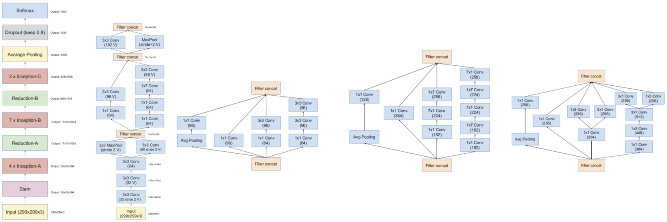

Besides, the following three important features are incorporated into the model architecture for optimization.

- label smoothing regularization.
This is a regularization method in " Rethinking the Inception Architecture for computer vision" . In classification problems, sometimes our model would learn to predict the training examples extremely confidently. This is not good for generalization. Label smoothing is able to prevent the model from predicting the training examples too confidently.
- Data augmentation
We adopt this method to generate more training data by horizontal flipping and elastic distortion (Simard et al, 2003), which has been proved to significantly decrease the error rate based on paper "Understanding data augmentation for classification: when to warp?".
- Dropout
A dropout layer with keep_prob value of 0.5 was added to the last but one layer to prevent over-fitting.

Performance of the model on Fashion MNIST
We trained the model with 100 epochs and obtained 94.5% accuracy on the test set with saved best model.

Reason to choose Inception V4
I referred to " Benchmark Analysis of Representative Deep Neural Network Architectures" about the time / space / accuracy complexity analysis of Inception V4 model.
- Accuracy VS Computational complexity & Space

The ball charts in below figures (a) and (b) show Top-1 and Top-5 accuracy on the ImageNet-1k validation set with respect to the computational complexity of the considered architectures for a single forward pass measured. The ball size corresponds to the model complexity.
The computational complexity of each model considered is measured by floating-point operations (FLOPs) in the number of multiply-adds.
From the two figures we can see Inception V4 model is one of the models with the highest accuracy and moderate model complexity (50M) and moderate computational complexity (12 FLOPs). On the other hand, models with low model complexity and computational cost always comes with low accuracy.

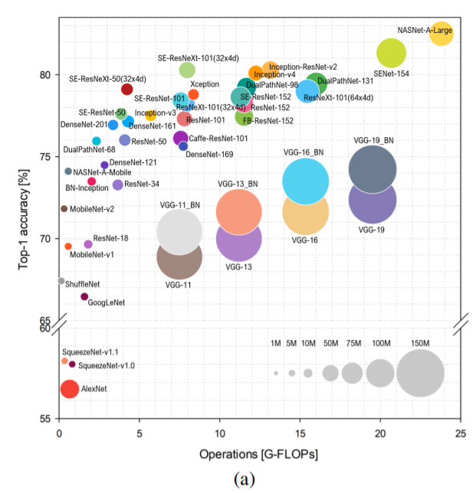
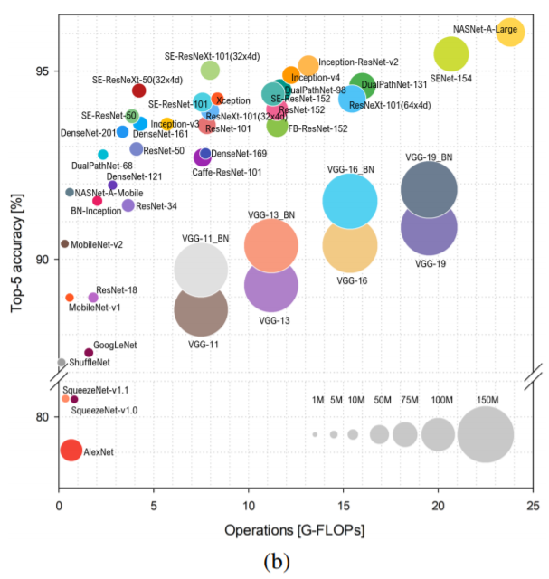
2.Inference time
Average per image inference time over 10 runs for all the DNN models considered are reported in the table below for batch size equal to 1, 2, 4, 8, 16, 32, and 64 on the Titan Xp. Inference time is measured in milliseconds. From the table it is possible to see that all the DNN models considered are able to achieve super real-time performances. The models with high accuracy like Inception-Resnet-V2 ,SE-ResNeXt-101 and Inception V4 will have relatively longer inference time compared to simpler models like AlexNet and Inception V3, but is still considered as real-time processing.
